Car Pooling
Objective:
Car Pooling is an online application to be built as a product that enables the
corporate employees within an organization to avail the facility of car
pooling effectively.
Users of the System:
- Admin
- Employees
Functional Requirements:
- A system for an Admin who can enter the employee details like name, contact number, vehicle details etc
- Corporate employees can register the details to the website.
- The facility to check whether the vehicle and driver is authorized or not
- Admin can view the report of the car pooling process to improve the system
- Employees can report suggestions/complaints in the website
- Employees receive SMS alerts regarding the route and timings.

While the above ones are the basic functional features expected, the below ones can be nice to have add-on features:
- Secure access of confidential data (car pooling details).
- Flexible service based architecture will be highly desirable for future extension
Output/ Post Condition:
- System will generate Monthly Reports and Weekly Reports

Non-Functional Requirements:

Security | - App Platform –UserName/Password-Based Credentials  - Sensitive data has to be categorized and stored in a secure manner  - Secure connection for transmission of any data
Performance | - Peak Load Performance  - Car Pooling -< 3 Sec  - Admin application < 2 Sec  - Non Peak Load Performance
Availability | - 99.99 % Availability
Standard Features | - Scalability  - Maintainability  - Usability  - Availability  - Failover
Logging & Auditing | - The system should support logging(app/web/DB) & auditing at all levels
Monitoring | - Should be able to monitor via as-is enterprise monitoring tools
Cloud | - The Solution should be made Cloud-ready and should have a minimum impact when moving away to Cloud infrastructure
Browser Compatible | - IE 7+  - Mozilla Firefox Latest – 15  - Google Chrome Latest – 20  - Mobile Ready

Technology Stack
Front End | Angular 7+  Google Material Design  Bootstrap / Bulma
Server Side | Spring Boot  Spring Web (Rest Controller)  Spring Security  Spring AOP  Spring Hibernate
Core Platform | OpenJDK 11
Database | MySQL or H2

Platform Pre-requisites (Do’s and Don’ts):
- The angular app should run in port 8081. Do not run the angular app in the port: 4200.
- Spring boot app should run in port 8080.

Key points to remember:
- The id (for frontend) and attributes(backend) mentioned in the SRS should not be modified at any cost. Failing to do may fail test cases.
- Remember to check the screenshots provided with the SRS. Strictly adhere to id mapping and attribute mapping. Failing to do may fail test cases.
- Strictly adhere to the proper project scaffolding (Folder structure), coding conventions, method definitions and return types.
- Adhere strictly to the endpoints given below.

Application assumptions:
- The login page should be the first page rendered when the application loads.
- Manual routing should be restricted by using AuthGaurd by implementing the canActivate interface. For example, if the user enters as http://localhost:4200/signup or http://localhost:4200/home the page should not navigate to the corresponding page instead it should redirect to the login page.
- Unless logged into the system, the user cannot navigate to any other pages.
- Logging out must again redirect to the login page.
- To navigate to the admin side, you can store a user type as admin in the database with a username and password as admin.
- Use admin/admin as the username and password to navigate to the admin dashboard.

Validations:
- Basic email validation should be performed.
- Basic mobile validation should be performed.
Project Tasks:
API Endpoints:
USER
Action | URL | Method | Response
Login | /login | POST | true/false
Signup | /signup | POST | true/false
Get Routes | /route | GET | Array of Route
Get RouteById | /route/{id} | POST | Route Details
Edit Customer | /editCustomer/{id} | PUT | Success
New Booking | /saveBooking | POST | Cart items added to the Orders list
Remove Booking | /deleteBooking | DELETE | Booking removed
ADMIN
Action | URL | Method | Response
Get Employee | /admin/getEmployee | GET | Array of Employee
Get EmployeeById | /admin/getEmployeeById/{id} | GET | Employee Details
Delete Employee | /admin/delete/{id} | DELETE | Employee Delete
Edit Employee | /admin/editEmployee/{id} | GET | Get All details of Particular id
Save Employee | /admin/saveEmployee/{id} | POST | Save new employees
Get All routes | /admin/routes | GET | Array of Routes
Add Route | /admin/addRoutes | POST | Routes added successfully
Edit Routes | /admin/editRoutes/{id} | PUT | Successfully routes edited
Delete Route | /admin/deleteRoutes | DELETE | Routes deleted successful

Frontend:
Employees:
Login:
Output Screenshot:
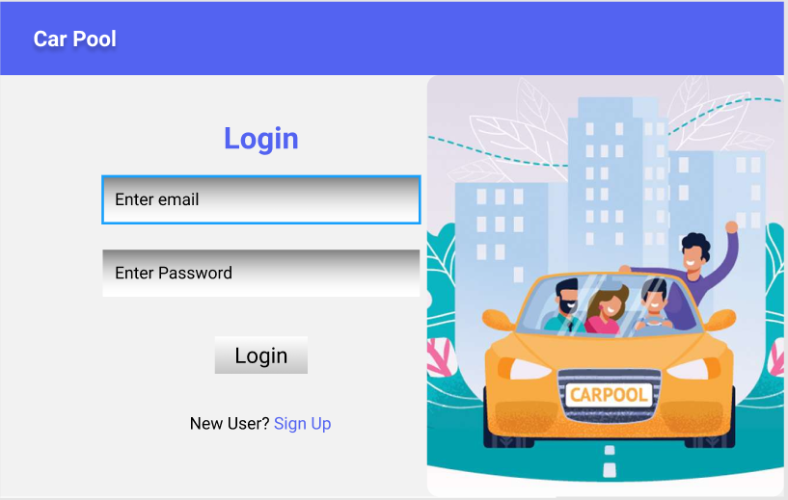

Signup:
Output Screenshot:
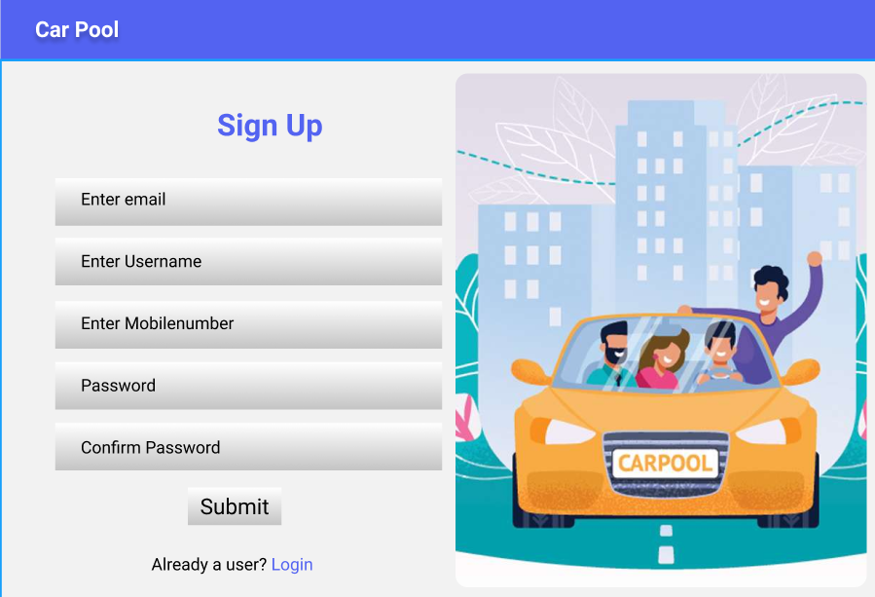
Home:
Output Screenshot:
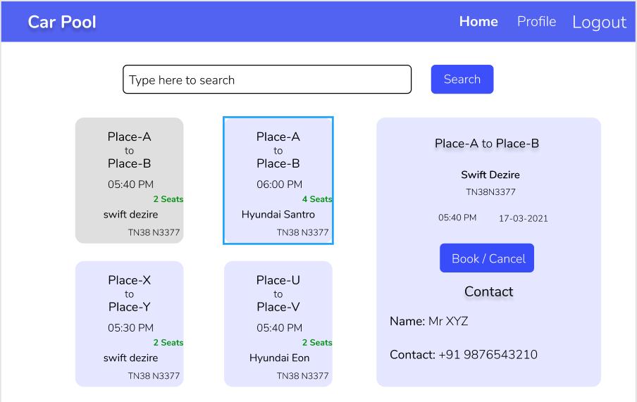
Profile:
Output Screenshot:
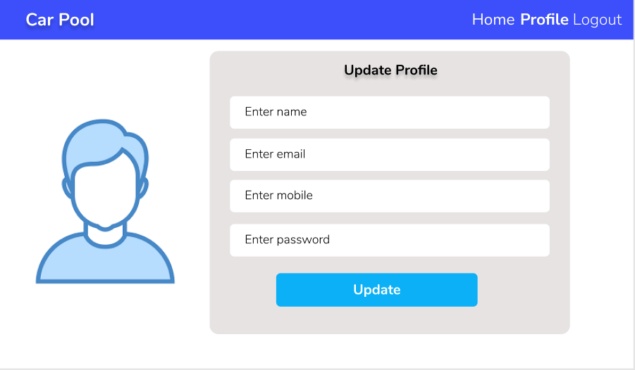

Admin:
Home:
Output Screenshot:
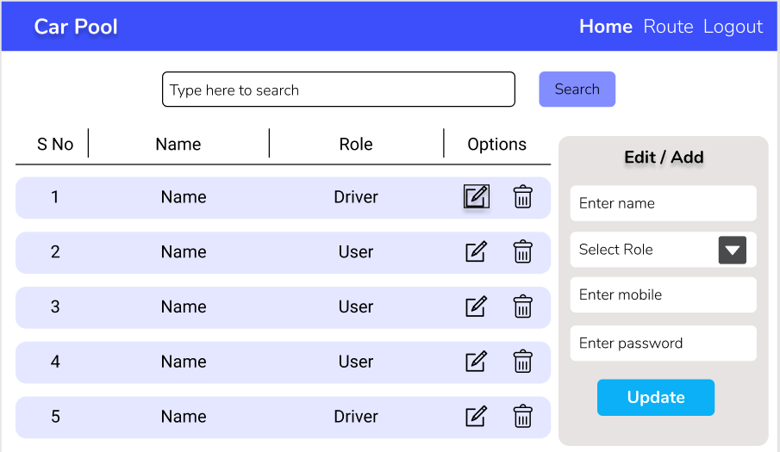

Route:
Output Screenshot:
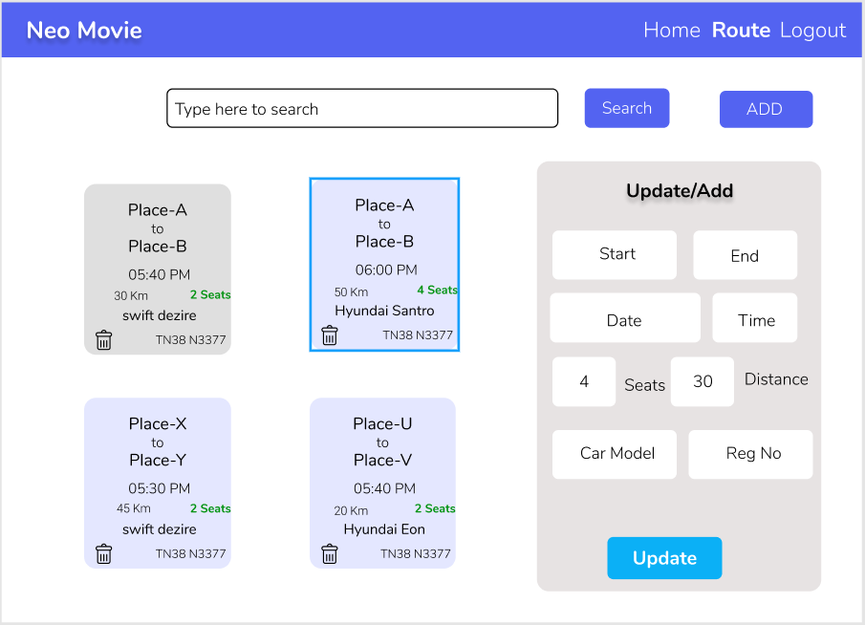
Backend:
Class and Method description:

Model Layer:

- EmployeesModel: This class stores the details of the Employees information.
  - Attributes:
    - username: String
    - password: String
    - email: String
    - mobileNumber: Long
    - vehicleModel: String
    - vehicleNumber: String
    - verified: Boolean
    - active: Boolean
  - Methods: -
- LoginModel: This class contains the email and password of the user.
  - Attributes:
    - email: String
    - password: String
  - Methods: -
- CustomerModel: This class stores the details of the Corporate Employees.
  - Attributes:
    - customerId: String
    - customerName: String
    - emailId: String
    - mobileNumber: Long
    - status: Boolean
  - Methods: -
- RouteModel: This class stores the route details.
  - Attributes:
    - routeId: int
    - startPoint: String
    - endPoint: String
    - distance: int
  - Methods: -

Controller Layer:
- SignupController: This class control the user signup
  - Attributes: -
  - Methods:
    - saveCustomer(CustomerModel user): This method helps to store Customer in the database and return true or false based on the database transaction.
- LoginController: This class controls the user login.
  - Attributes: -
  - Methods:
    - checkUser(LoginModel data): This method helps the user to sign up for the application and must return true or false
- EmployeeController: This class controls the add/edit/update/view Employees.
  - Attributes: -
  - Methods:
    - List<EmployeModel> getEmployee(): This method helps the admin to fetch all employees from the database.
    - EmployeModel getEmployeeById(String id): This method helps to retrieve a Employee from the database based on the employee id.
    - EmployeeModel editEmployee(EmployeeModel data): This method helps to edit a employee and save it to the database.
    - saveEmployee(EmployeeModel data): This method helps to add a new employee to the database.
    - deleteEmployee(String id): This method helps to delete a Employee from the database.
- RouteController: This class helps in add, delete, update, delete the Route.
a. Attributes: -
b. Methods:
    - List<RouteModel> getRoute(): This method helps the Customer to fetch all route from the database.
    - RouteModel getRouteById(String id): This method helps to retrieve a Route from the database based on the route id.
    - RouteModel editRoute(RouteModel data): This method helps to edit a route and save it to the database.
    - saveRoute(RouteModel data): This method helps to add a new Route to the database.
    - deleteRoute(String id): This method helps to delete a Route from the database.
- BookingController: This class helps to booking the car.
  - Attributes: -
  - Methods:
    - List<BookingModel> getBooking (): This method helps the admin to fetch all booking from the database.
    - BookingModel getBookingById(String id): This method helps to retrieve a Booking from the database based on the userId.
    - saveBooking(BookingModel): This method helps the customer to add a new Bookingto the database.

